set-13
25.Write a Python program to plot two or more lines with legends, different widths and
colors.
Code:
import matplotlib.pyplot as plt
x = [1,2,3,4,5]
y1 = [2,4,6,8,10]
y2 = [1,3,5,7,9]
plt.plot(x, y1, label="Line 1", linewidth=3, color="blue")
plt.plot(x, y2, label="Line 2", linewidth=2, color="red")
plt.xlabel("X")
plt.ylabel("Y")
plt.title("Multiple Lines")
plt.legend()
plt.show()
Output:
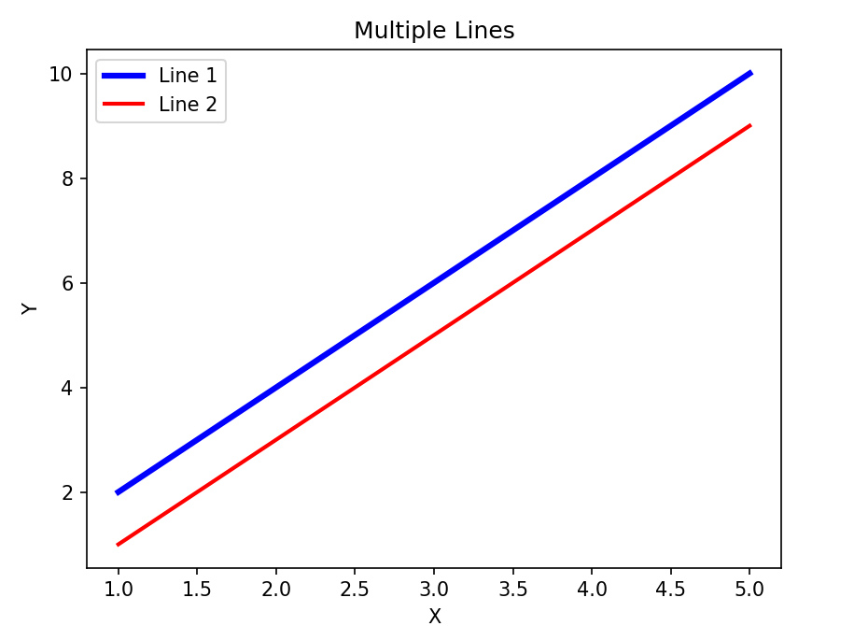
26.Write a Python program to create multiple plots.
Code:
import matplotlib.pyplot as plt
plt.subplot(2,1,1)
plt.plot([1,2,3],[2,4,6])
plt.title("First Plot")
plt.subplot(2,1,2)
plt.plot([1,2,3],[6,4,2])
plt.title("Second Plot")
plt.tight_layout()
plt.show()
Output:
